**Facebook used less for news as discussion and debate moves to newer networks and messaging apps**

The use of social media for news has started to fall in a number of key markets – after years of continuous growth, according to the seventh annual *Digital News Report* from the Reuters Institute for the Study of Journalism at the University of Oxford. The report, which is based on a YouGov online survey conducted with 74,000 people in 37 countries, says that much of the fall is attributable to Facebook’s changed algorithms, but that users are also worried about privacy, the toxic nature of debates on the platform and how to distinguish between real and ‘fake’ news’. The report finds that just 23% trust news on social media, compared with 34% for search, 44% for trust in news overall, and 51% for sources that people use themselves.

The report offers some positive news for news organisations that are looking to build direct relationships with consumers and refocus on quality journalism. The number of people paying for online news is up in a number of countries, email and mobile notifications are helping to create greater loyalty, while new business models such as membership and donations are beginning to gain traction.

**PROPORTION THAT SAY THEY TRUST NEWS FROM EACH SOURCE**

**ALL MARKETS**

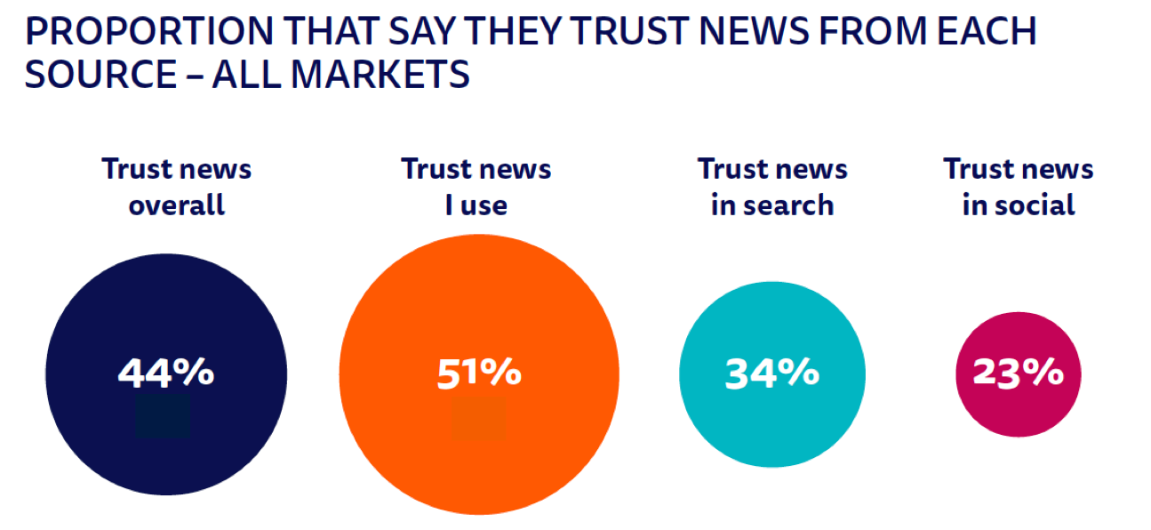

**Q6_2018_1/2/3/4.** Please indicate your level of agreement with the following statements. I think you can trust ‘most news’/’news I consume’/’news in social media’/’news in search engines’ most of the time. *Base: Total sample in all markets = 74194.*

**More on Facebook decline for news and move to messaging**

While overall use of Facebook remains high and stable, the number of people who use it for news is declining in most markets. News consumption via Facebook is down 9 percentage points in the United States, compared with 2017, and down 20 points with younger groups. At the same time we have seen a rise in the usage for news of alternative platforms such as WhatsApp, Instagram, and Snapchat – particularly with younger groups. WhatsApp use for news has tripled, on average, in four years to 15%, but tends to be much higher in countries like Malaysia (54%) and Turkey (30%) where it can be dangerous to express political views in more open networks.

**PROPORTION THAT USED EACH SOCIAL NETWORK FOR NEWS IN THE LAST WEEK (2014-18)**

**SELECTED MARKETS**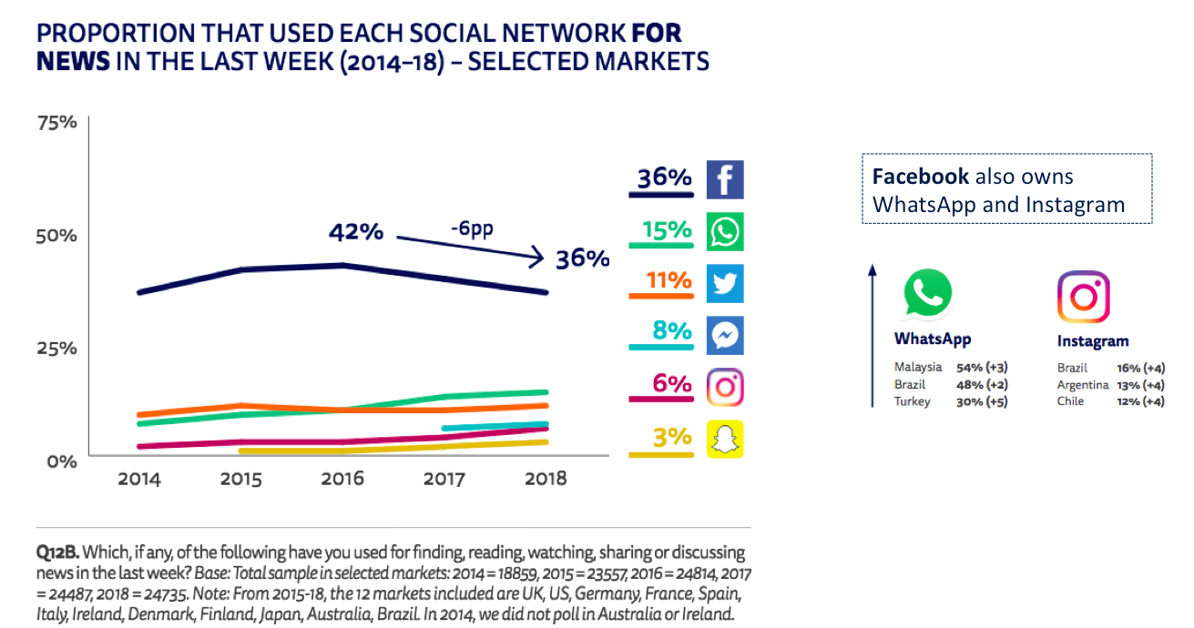

**Q12B.** Which, if any, of the following have you used for finding, reading, watching, sharing or discussing news in the last week? *Base: Total sample in selected markets: Note: From 2015-18, the 12 markets included are UK, US, Germany, France, Spain, Italy, Ireland, Denmark, Finland, Japan, Australia, Brazil. In 2014, we did not poll in Australia or Ireland.*

Facebook algorithm changes have clearly played a part as the company prioritises interactions with family and friends and tries to limit the impact of ‘fake’ news. But focus group evidence suggests some consumer behaviour is changing too.

*I’ve actually pulled back from using Facebook a lot since the whole political landscape changed over the last few years because I just find everyone’s got an opinion.   
(F, 30–45, UK focus group)*

Respondents often talk about *finding* stories on Facebook (and Twitter) but then posting them to a WhatsApp group for *discussion* with a smaller, closer set of friends. Report lead author Nic Newman says

*We are seeing many switching their focus to more personal, private spaces like messaging apps for sharing and discussing news. This gives people more control over where and how they engage, but also potentially makes public debate and news distribution even more fragmented and opaque*

**Concern about misinformation spreads across the world**

Over half of those polled (54%) say they are concerned about whether news is real or ‘fake’ on the internet. This is highest in countries like Brazil (85%), Spain (69%), and the United States (64%) where polarised political situations combine with high social media use. It is lowest in Germany (37%) and the Netherlands (30%) where recent elections were largely untroubled by concerns over ‘fake’ content.

Most respondents believe that publishers (75%) and platforms (71%) have the biggest responsibility to fix problems of ‘fake’ and unreliable news. This is because much of the news they complain about relates to biased or inaccurate news from the mainstream media rather than news that is completely made up or distributed by foreign powers. But the appetite for government intervention over misinformation differs greatly. Support in Europe (60%) and Asia (63%) contrasts with reticence in the US where only four in ten (41%) thought that government should do more.

**PROPORTION WHO SAY THEY ARE CONCERNED ABOUT WHAT IS REAL AND WHAT IS FAKEON THE INTERNET WHEN IT COMES TO NEWS**

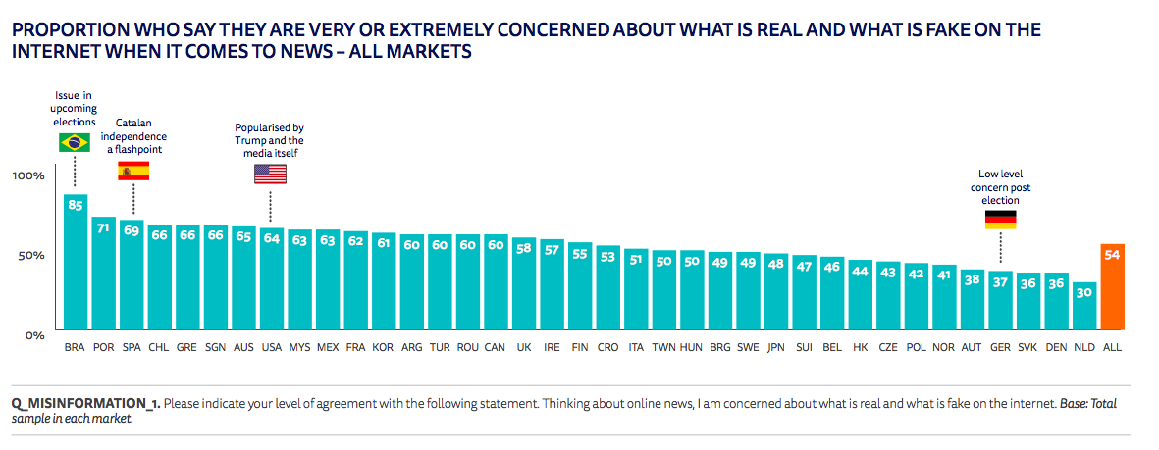

**Q_FAKE_NEWS_1.** Please indicate your level of agreement with the following statement. Thinking about online news, I am concerned about what is real and what is fake on the internet. *Base: Total sample in each market.*

Professor Rasmus Kleis Nielsen, one of the report’s editors and Director of Research at the Reuters Institute for the Study of Journalism, says

*Many clearly hold the major platform companies responsible for problems of disinformation, but even more see publishers as responsible for unreliable news. The whole discussion around disinformation is about digital media, but the frequent use of the dangerous and misleading term “fake news” resonates with a long-standing crisis of confidence, where much of the public does not feel it can trust the news, especially in countries with highly polarized politics and where many media are vulnerable to undue economic or political influence.*

**Business models continue to evolve**

This year’s report contains mixed news for publishers looking to build sustainable online revenue. Nordic countries have seen significant increases in the numbers paying for online with Norway reaching 30%(+4), Sweden 26% (+6) and Finland 18% (+4). All these countries have a small number of publishers, the majority of whom are relentlessly pursuing a variety of paywall strategies. By contrast more complex and fragmented markets in Europe have seen little subscription growth despite increased attempts to charge for some online content.

Last year’s significant increase in digital subscriptions in the United States (the so-called Trump Bump) has been maintained, while donations and donation-based memberships are emerging as a significant alternative strategy in Spain, and the UK as well as in the United States. These payments are closely linked with political belief (the left) and come disproportionately from the young. The Guardian is one publisher that has attracted hundreds of thousands of donations and the survey suggests that about a quarter might be prepared to pay in the future if publishers are unable to cover costs in other ways (see chart).

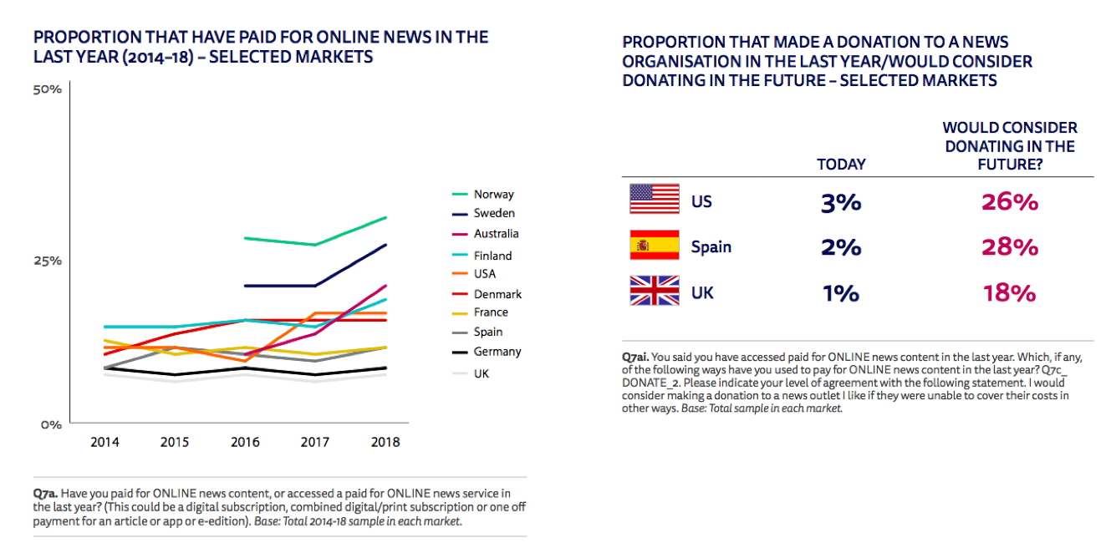

**Q7a.** Have you paid for ONLINE news content, or accessed a paid for ONLINE news service in the last year? (This could be a digital subscription, combined digital/print subscription or one off payment for an article or app or e-edition). *Base: Total 2014-18 sample in each market.*

The report also reveals that more than two-thirds of respondents (68%) are either unaware of the financial problems of the news industry or believe that most news organisations are making a profit from digital news. Those that were aware that most digital newspapers are making a loss are more likely to pay for a news subscription or give a donation.

Professor Rasmus Kleis Nielsen says

*The verdict is clear: people find that some news is worth paying for, but much of it is not. The challenge for publishers now is to ensure that the journalism they produce is truly distinct, relevant, and valuable, and then effectively promoting it to convince people to donate or subscribe*

**Other headlines from this year’s report**

* For the first time the report measures and looks at the impact of news literacy. It finds that those with higher literacy tend to prefer newspapers brands over TV, and use social media for news very differently from the wider population. They are also more cautious about interventions by governments to deal with misinformation.
* In many countries the report finds accelerating annual declines in audience for television news and especially for scheduled news bulletins. These trends are affecting many public broadcasters that are struggling to attract online audiences and especially engage young people
* Podcasts are becoming popular across the world due to better content and easier distribution. They are used almost twice as often in the United States (33%) as they are in the UK (18%). Young people are far more likely to use podcasts than listen to speech radio.
* Voice-activated digital assistants like the Amazon Echo and Google Home continue to grow rapidly, opening new opportunities for news audio. Usage has more than doubled in the United States, Germany, and the UK with around half of those who have such devices using them for news and information.
* Consumers remain reluctant to consume news video within publisher websites. Over half of consumption happens in third-party environments like Facebook and YouTube. Americans and Europeans would like to see fewer online news videos; Asians tend to want more.
* 18% regularly access news related emails with 16% using mobile notifications weekly. In some countries users are starting to complain they are being bombarded with too many messages while 37% of those not currently getting notifications and alerts say *nothing* would encourage them to do so.

**Brand Trust Scores**

With Facebook looking to incorporate survey-driven brand trust scores into its algorithms, the report reveals, for the first time, results for top news brands in each of the 37 countries based on similar methodologies. The survey shows that brands with a broadcasting background or long heritage tend to be trusted most – suggesting that popular newspapers and digital-born brands could get less visibility in social media in future along with brands that contain extreme or partisan content. In the United States we find that local television news is most trusted, with a mean score of over six out of ten (6.5), and Breitbart least trusted (3.69). However for those who use Breitbart regularly, the trust score jumps to 6.96 reflecting its highly partisan user base. Trust is also strongly affected by political affiliation. In the UK, the public broadcaster BBC scores best with popular newspapers and digital born brands scoring lowest.

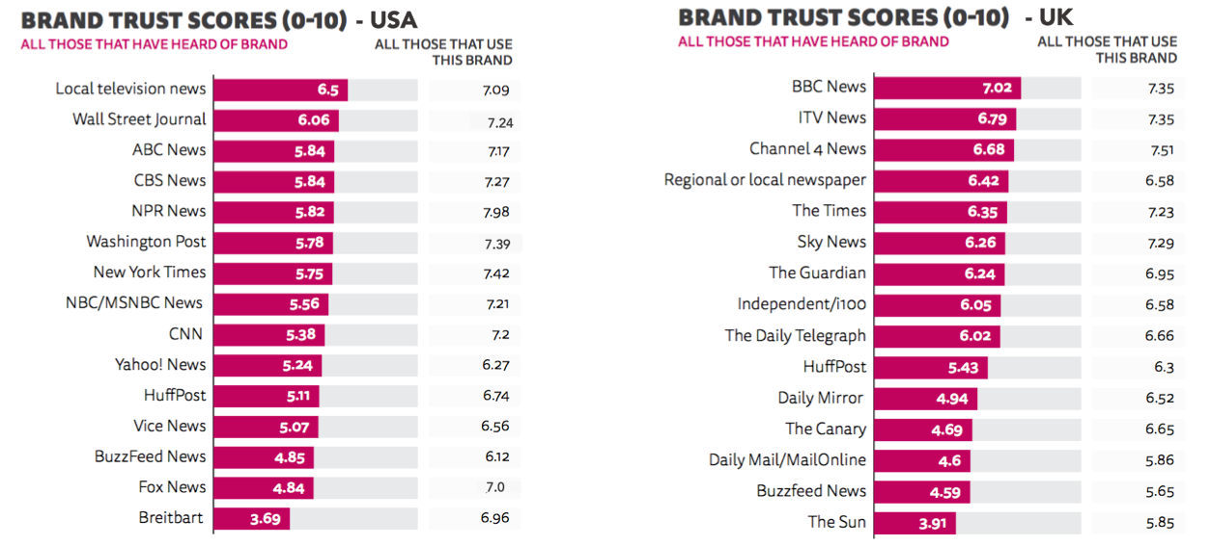Q6_2018. How trustworthy would you say news from the following brands is? Use the scale below, where 0 is ‘not at all trustworthy’ and 10 is ‘completely trustworthy’.   
*Base: Total sample/all who used each brand in the last week. Note: People who indicated that they have not heard of a brand were excluded. Bases vary for users of each brand, but all were above 50.*

**METHODOLOGY**

All figures, unless otherwise stated, are from YouGov Plc.  Survey conducted in 37 countries; United States, United Kingdom, Germany, France, Italy, Spain, Portugal, Ireland, Norway, Sweden, Finland, Denmark, Belgium, Netherlands, Switzerland, Austria, Hungary, Slovakia, Czech Republic, Poland, Croatia, Romania, Bulgaria, Greece, Turkey*, South Korea, Japan, Hong Kong, Malaysia, Taiwan, Singapore, Australia, Canada, Brazil*, Argentina, Chile and Mexico*.

Total sample size was 74194 adults with around 2000 per country. Fieldwork was undertaken at the end of January/start of February 2018.

The survey was carried out online. The data were weighted to targets set on age, gender and region, to reflect the total population. The sample is reflective of the population who have access to the internet and respondents were screened out if they had not accessed news in the last month.

*Please note that Brazil, Turkey and Mexico are representative of an urban population rather than a national population. As such the internet penetration is likely to be higher than for the country as a whole, which must be taken into consideration when interpreting results.

Focus groups carried out by Kantar Research in February 2018 in the USA, UK, Germany and Brazil. Participants had high/mid-level interest in news and were regular users of both social media and messaging aps. Groups were split into sessions for 20-29s and 30-45s in each country.

**CONTACT:**

**For more information, interview requests or for a copy of the full report, please contact Caroline Lees,**[**caroline.lees@politics.ox.ac.uk**](mailto:caroline.lees@politics.ox.ac.uk)**tel: 01865 611098; 07779 422497 @risj_oxford #DNR18**

**MORE INFORMATION ON 2018 REPORT**

The research and report can also be found on a dedicated website ([www.digitalnewsreport.org](http://www.digitalnewsreport.org/)) from 14th June containing slidepacks, charts, and raw data tables, with a licence that encourages reuse. A description of the methodology is available with the complete questionnaire.

This is the seventh in an annual series of reports that will track the transition of the news industry towards an increasingly digital and multi-platform future.

Sponsors of this year’s report include Google, BBC News, Ofcom, Edelman UK, the Broadcasting Authority of Ireland (BAI), the Media Industry Research Foundation of Finland, the Fritt Ord Foundation in Norway, the Dutch Media Authority (CvdM), the Korea Press Foundation, as well as our academic sponsors at the Hans Bredow Institute, Hamburg University, the University of Navarra, the University of Canberra and Le Centre d’études sur les médias, Université Laval in Canada and Roskilde University in Denmark. Sole responsibility for the analysis, interpretation and conclusions drawn lies with the authors and editors of the Report

**Reuters Institute for the Study of Journalism**  
The Thomson Reuters Foundation is the core funder of the Reuters Institute, based in the Department of Politics and International Relations at the University of Oxford. The Institute was launched in November 2006 and developed from the Reuters Fellowship Programme, established at Oxford 35 years ago. The Institute, an international research centre in the comparative study of journalism, aims to be global in its perspective and provides a leading forum for scholars from a wide range of disciplines to engage with journalists from around the world. See <http://reutersinstitute.politics.ox.ac.uk/>

**Nic Newman - Lead Author and Joint Editor**  
Journalist and digital strategist who played a key role in shaping the BBC’s internet services over more than a decade. Nic is currently a Research Associate at the Reuters Institute for the Study of Journalism at the University of Oxford and a consultant on digital media.

**Richard Fletcher - Author**   
Research Fellow at the Reuters Institute for the Study of Journalism. He is a data and survey specialist primarily interested in global trends in digital news consumption.

**Antonis Kalogeropoulos – Author**Research Fellow at the Reuters Institute for the Study of Journalism. His research interests include political communication, journalism, and audience research.

**David Levy** – **Joint Editor**  
Director of the Reuters Institute, a Fellow of Green Templeton College and an expert in media policy and regulation. He previously worked at the BBC both as a news and current affairs producer, reporter, and editor, and later as Controller of Public Policy.

**Rasmus Kleis Nielsen** **– Joint Editor**  
Director of Research at the Reuters Institute for the Study of Journalism, Professor of Political Communication at the University of Oxford, and Editor in Chief of the [*International Journal of Press/Politics*](http://hij.sagepub.com/). His work focuses on changes in the news media, political communication, and the role of digital technologies in both.

**About YouGov**YouGov is an international market research agency and pioneer of market research through online methods. YouGov has a panel of 5 million people worldwide, including 1 million in the UK representing all ages, socio-economic groups and other demographic types.