**Half of online users (51%) now get news from Facebook and other social platforms, raising dilemmas for publishers, says new international study**

A second wave of disruption has hit news organisations around the world, with potentially profound consequences both for publishers and the future of news production, according to the world’s most authoritative report on digital news.

The fifth Digital News Report from the Reuters Institute for the Study of Journalism at the University of Oxford highlights the combined impact of the rise of social platforms, an accelerating move to mobile devices and growing consumer rejection of online advertising, as undermining many of the business models that support quality news. The report shows in particular how third-party platforms such as Facebook have moved beyond news discovery to become destinations for consumption over the last year with new product initiatives such as Instant Articles and distributed native video also playing an important role.

Reuters Institute Director of Research Rasmus Kleis Nielsen said:

*“The move towards a more distributed environment offers publishers opportunities to reach new audiences on an unprecedented scale, but as people increasingly access news via third party platforms, it will become harder and harder for most publishers to stand out from the crowd, connect directly with users, and make money. This development will leave some winners, and many losers.*

The report, based on survey research conducted in 26 countries, also reveals the extent of ad-blocking around the world while progress towards getting consumers to pay for online news remains slow. Together with falls in print circulation and advertising in many countries, the report documents how these trends are leading to job losses, consolidation and moves towards online-only operations. Despite this, the report highlights the continuing importance of a number of ‘anchor news brands’ with a strong journalistic track record, which are valued by users as a critical source of trusted news.

**The rise of distributed content and the role of Facebook**Half of all online users across the 26 countries (51%) now say they use social media as a source of news each week. Around one in ten (12%) now say this is their main source. The report shows the increasingly influential role played by Facebook in the distribution of online news with 44% using the network to find, read, watch, share, or comment on the news each week – more than twice that of its nearest rival. You Tube (19%) also plays a role in some countries, while Twitter (10%), despite its business problems, remains important for heavy news users and influencers.

Social media are significantly more important for women (who are also less likely to go directly to a news website or app) and for the young. More than a quarter of 18–24s say social media (28%) are their main source of news – more than television (24%) for the first time.

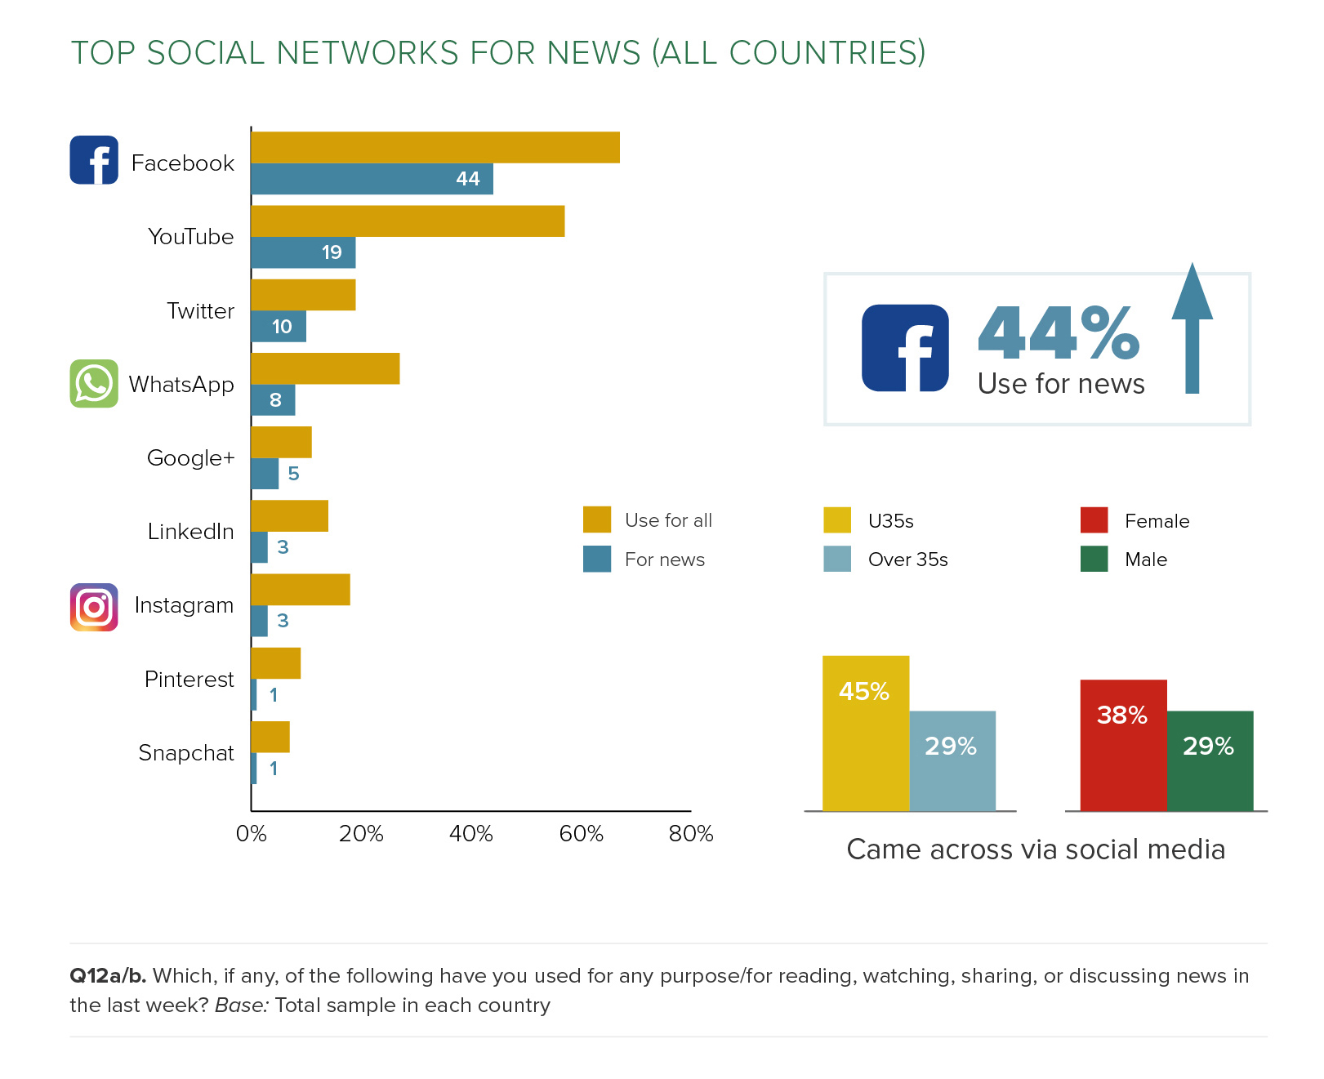

Of the other new platform players, Apple News (4% in the US and 3% in the UK) has so far failed to have much impact. Snapchat is used for news by just 1% or less in most countries, though Snapchat Discover reaches 12% of 18-24s in the United States.

The growth of news accessed and increasingly consumed via social networks, portals and mobile apps means that the originating news brand gets clearly noticed less than half the time in countries like the UK, and Canada. In Japan and South Korea, where distributed news is already more widespread, the brand only gets noticed around a quarter of the time when accessed through aggregators.

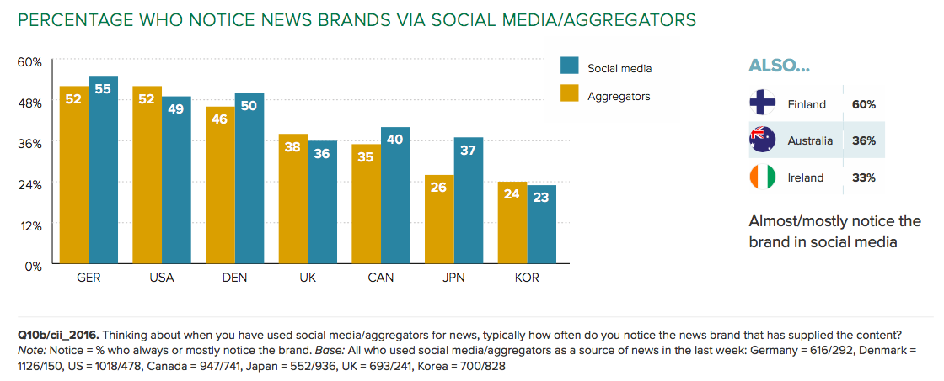

**Algorithms vs Editors**

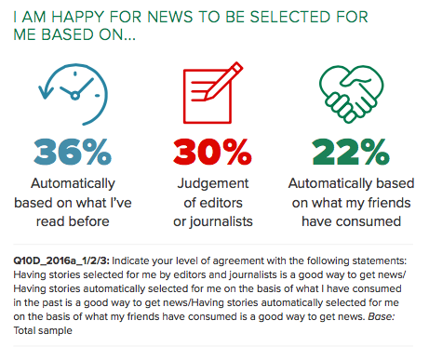A generation that prefers the news to be selected by computers rather than humans has emerged with surprising speed. The research shows that many consumers are more comfortable with choices decided by algorithms rather than by editors or journalists – especially if based on personal reading history. At the same time online users expressed concern about the consequences of more personalised news, with the British amongst those who most fear that key information (65%) or challenging viewpoints (61%) might be lost in an algorithmically driven filter bubble. Germans, Austrians and Koreans were more concerned about the privacy implications of personalised and algorithmically driven news.

**Smartphone news use surges, tablet levels off**

Over half of all respondents (53%) now say they use a smartphone to access news, with some of the highest levels in Sweden (69%), Korea (66%), and Switzerland (61%). Average weekly usage has grown from 44% to 48% in the US and from 42 to 46% in the UK where the number saying they *mainly* use a mobile device for news has overtaken computers and laptops for the first time. By contrast weekly tablet usage for news has fallen in the UK with growth slowing elsewhere.

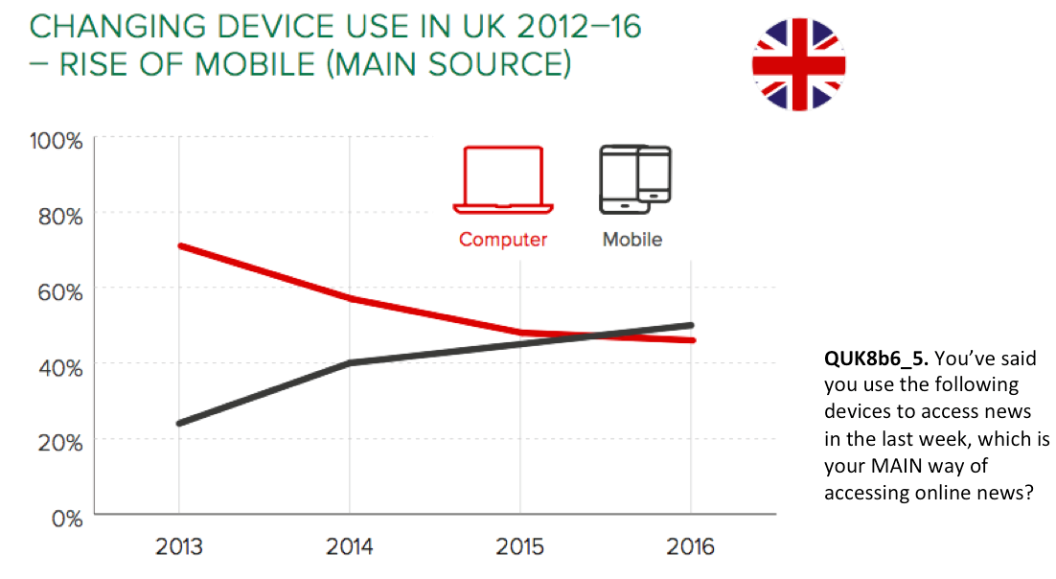

A significant proportion comes into contact with news via a smartphone first thing in the morning (16% in the UK and 17% in the US), rather than using a TV, radio or newspaper. Of these almost half of Americans (48%) and a third of Britons (33%) access news first via social media rather than a news app or website.

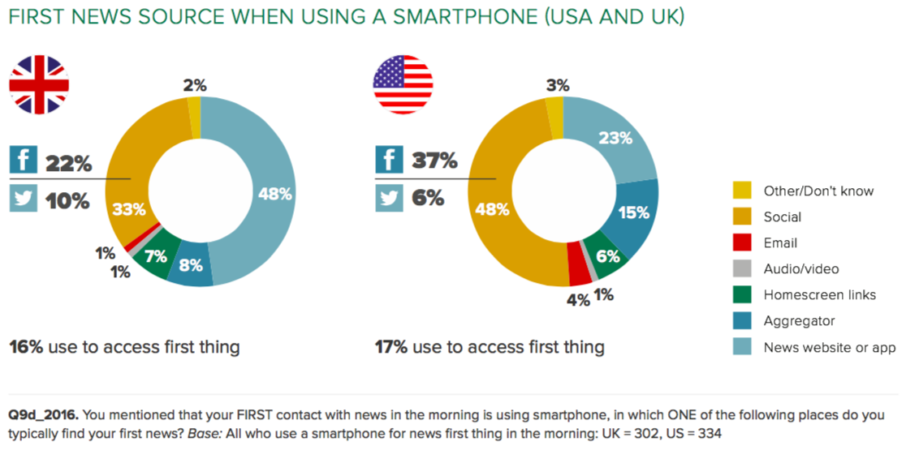

When using a smartphone, the report data shows that users are more likely to use social media and are less likely to go directly to a news website or app than when using a computer or tablet.

Lead author Nic Newman points out:

*“The move to smartphone goes hand-in-hand with the move to distributed content. Mobile users increasingly find news coming to them through social media feeds, alerts and notifications”*

**Paying for online news**

Sales of printed newspapers have continued to fall in most countries covered by the report but this year’s data show little increase in the proportion prepared to pay for online news content. It is striking that no English-speaking country has a payment rate of more than 10% – likely to be a consequence of widespread availability of free news and the intense global competition for digital eyeballs. By contrast some smaller countries protected by geography or language have been able to achieve rates of 20% or more, particularly where there is a tradition of newspaper subscription via home delivery to build on.

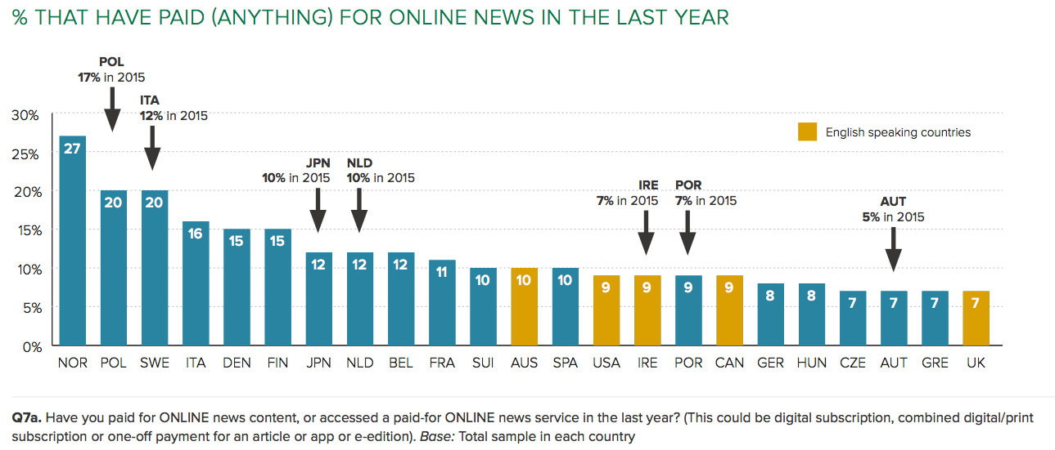

Although the UK has the lowest headline percentage, it has a high proportion of ongoing subscriptions and a high average annual payment per person. By contrast countries like Italy, Poland and Spain rely on one-off payments with a lower rate of return. A strong online presence by a public service broadcaster (PSB) does not seem to be a barrier to paying for online news. Norway, Sweden, and Finland all have strong PSBs and high levels of payment. By contrast, the United States has no significant public broadcasting tradition but has relatively low levels of online payment.

**Ad-blocking**

Many of the hardest hit publishers have been those who depend on digital advertising revenue have seen their models by ad-blocking, which has weakened due to, the move to smaller mobile screens, the ability of Silicon Valley tech giants to attract the majority of new advertising, and the rise of ad-blocking.

The report notes that ad-blocking is running at between 10% (Japan) and 38% (Poland), but much higher amongst under-35s. Most of those who have ever downloaded a blocker are using them regularly, suggesting that once downloaded they rarely go back.

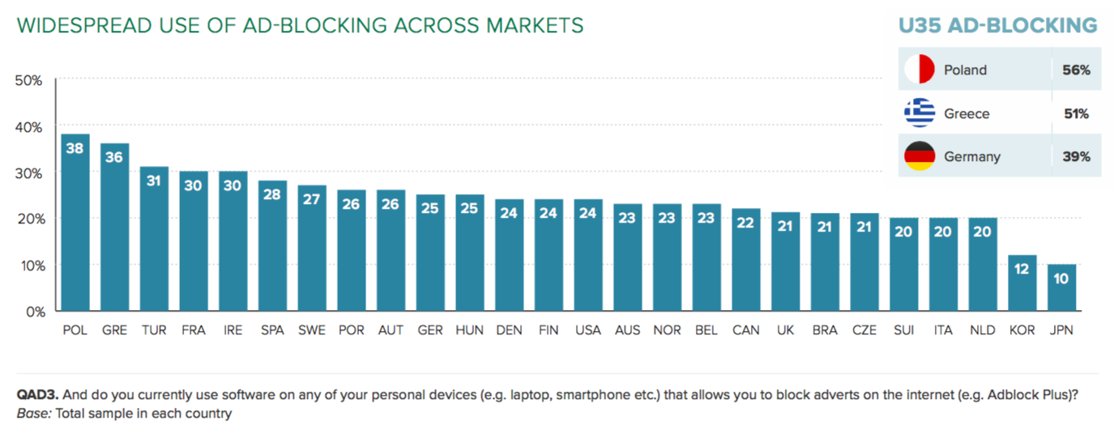Only around 8% of smartphone users currently use an ad-blocker but around a third of respondents (in the US, UK and Germany) say they plan toinstall one on their mobile in the next year.

**Video news not growing as fast as expected**

News organisations, which have thrown resources into video production, may be backing the wrong horse. Across all 26 countries only a quarter (24%) of respondents say they access online news video in a given week. This represents surprisingly weak growth given the explosive growth and prominence on the supply side. Video consumption is highest in the United States (33%), where there has been a significant ramp up in production by many news organisations – attracted by higher advertising premiums and better distribution opportunities in social media. By contrast, a weighted European average shows that less than a quarter (22%) are using video news in a given week with some of the lowest levels in Denmark (15%) and the Netherlands (17%). When pressed, the main reasons people give for not using more video are that they find reading news quicker and more convenient (41%) and the annoyance of pre-roll advertisements (35%).

Much of the growth in news video consumption has come through social networks in the last year. In countries that use social media the most – and with younger users, this is now majority behavior.

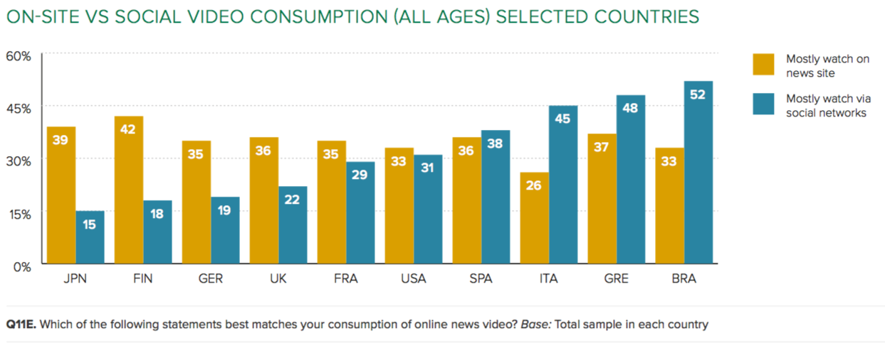

**Other key data points**

Derived from a detailed survey of the news consumption of over 50,000 online users in 26 countries, the Reuters Institute Digital News Report has become the prime source for identifying changes in the fast-changing news environment, as well as forecasting trends for the future.

* Five years’ worth of data show online now rivalling television as the most important news source in many countries with print readership continuing to fall[1]. Germany and France exhibit the most traditional behaviours with strong continuing preference for TV, radio, and print. By contrast, Korea, Norway, and Sweden have a strongly digital outlook, but traditional media remain both well used and valued.
* Television news still remains most important for older groups but overall usage has continued to decline, particularly for ‘appointment to view’ bulletins and amongst younger groups.
* Trust in news is highest in Finland (65%) and lowest in Greece (20%). Typically, affluent Western European and Scandinavian countries with a mix of strong, well-funded public service broadcasters and commercial players scored highly. Trust is lower in the United States (33%) as well as in Southern European countries. Almost everywhere, editors and journalists are trusted less than news organisations.

**Traditional media brands still matter**

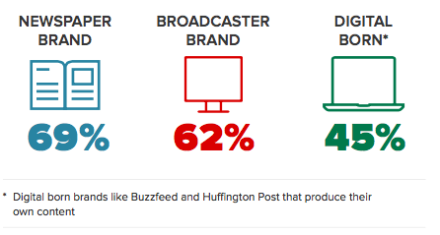Even in the era of social media and atomised media, the report suggests that traditional news brands still matter. Although gateways to news are changing fast, most of the content consumed still comes from newspaper groups, broadcasters, or digital born brands that have invested in original content. Media companies that have nailed their colours to a distributed future like BuzzFeed are gaining ground in terms of reach. But these new brands and platforms are mostly used as secondary sources and for softer news subjects. Main usage online remains with brands that have a strong news heritage and have been able to build up a reputation over time.   
  
Reuters Institute Director David Levy said:

*“Its clear that news is as popular as ever, and distinctive journalism is still valued by consumers. New brands are not yet replacing older ones in terms of the quality and range of output. The problem of how to pay for high quality but costly journalism becomes more pressing than ever”*

**METHODOLOGY**

All figures, unless otherwise stated, are from YouGov Plc.  Survey conducted in US, UK, Germany, France, Italy, Spain, Portugal, Ireland, Norway, Sweden, Finland, Denmark, Belgium, Netherlands, Switzerland, Austria, Hungary, Czech Republic, Poland, Greece, Turkey*, Korea, Japan, Australia, Canada, Brazil*.

Total sample size was 53,330 adults with around 2000 per country. Fieldwork was undertaken at the end of January/start of February 2016.

The survey was carried out online. The data were weighted to targets set on age, gender and region, to reflect the total population. The sample is reflective of the population who have access to the internet and respondents were screened out if they had not accessed news in the last month.

*Please note that Brazil and Turkey are representative of an urban population rather than a national population. As such the internet penetration is likely to be higher than for the country as a whole, which must be taken into consideration when interpreting results.

Interview requests or requests for data, charts, high res images should be sent to **Hannah Marsh** at the Reuters Institute [hannah.marsh@politics.ox.ac.uk](mailto:hannah.marsh@politics.ox.ac.uk)

**MORE INFORMATION ON 2016 REPORT**

The research and report can also be found on a dedicated website ([www.digitalnewsreport.org](http://www.digitalnewsreport.org/)) from 15th June containing slidepacks, charts, and raw data tables, with a licence that encourages reuse. A description of the methodology is available with the complete questionnaire.

This is the fifth in an annual series of reports that will track the transition of the news industry towards an increasingly digital and multi-platform future.

Sponsors of this year’s report include Google, BBC Global News, Ofcom, the Broadcasting Authority of Ireland (BAI), the Media Industry Research Foundation of Finland, the Fritt Ord Foundation in Norway, the Korea Press Foundation, Edelman UK, as well as our academic sponsors at the Hans Bredow Institute, the University of Navarra, the University of Canberra and Le Centre d’études sur les médias, Université Laval in Canada. Sole responsibility for the analysis, interpretation and conclusions drawn lies with the authors and editors of the Report

**Reuters Institute for the Study of Journalism**  
The Thomson Reuters Foundation is the core funder of the Reuters Institute, based in the Department of Politics and International Relations at the University of Oxford. The Institute was launched in November 2006 and developed from the Reuters Fellowship Programme, established at Oxford 33 years ago. The Institute, an international research centre in the comparative study of journalism, aims to be global in its perspective and provides a leading forum for scholars from a wide range of disciplines to engage with journalists from around the world. See <http://reutersinstitute.politics.ox.ac.uk/>

**Nic Newman - Lead Author and Joint Editor**  
Nic Newman is a journalist and digital strategist who played a key role in shaping the BBC’s internet services over more than a decade. Nic is currently a Research Associate at the Reuters Institute for the Study of Journalism at the University of Oxford and a consultant on digital media.

**Richard Fletcher - Author**   
Richard Fletcher is a Research Fellow at the Reuters Institute for the Study of Journalism. He is a data and survey specialist primarily interested in global trends in digital news consumption.  
  
**David Levy** – **Joint Editor**  
David Levy is Director of the Reuters Institute, a Fellow of Green Templeton College and an expert in media policy and regulation. He previously worked at the BBC both as a news and current affairs producer, reporter, and editor, and later as Controller of Public Policy.

**Rasmus Kleis Nielsen** **– Joint Editor**  
Rasmus Kleis Nielsen is Director of Research at the Reuters Institute for the Study of Journalism and Editor in Chief of the [*International Journal of Press/Politics*](http://hij.sagepub.com/). His work focuses on changes in the news media, political communication, and the role of digital technologies in both.

**About YouGov**YouGov is an international market research agency and pioneer of market research through online methods. YouGov has a panel of 3 million people worldwide, including over 600,000 people in the UK representing all ages, socio-economic groups and other demographic types.

For further information visit yougov.co.uk

1. NB these findings relate to those people who are online and will not be representative of the entire population. The survey will tend to under-represent the consumption habits of people who are not online

  